House No. XX, Street No. XX, Fazal Flat Nadeem Shaheed Road Samanabad Lahore.
+9 2-32 2-XXXXXXX

To have a challenge and tasks oriented jobs to foster confidence, enrich, experience and stimulate change and celebrate success.

PERSONAL INFORMATION

FATHER’S NAME DATE OF B I RTH ID CARD NO
RE LIGION NATIONAL I TY DOM ICILE
MUHAMMAD I FTI KHAR ALI
04-12-1982
3S 20 2- XXXXX3 ISLAM PAKISTANI LAHORE

EDUCATION

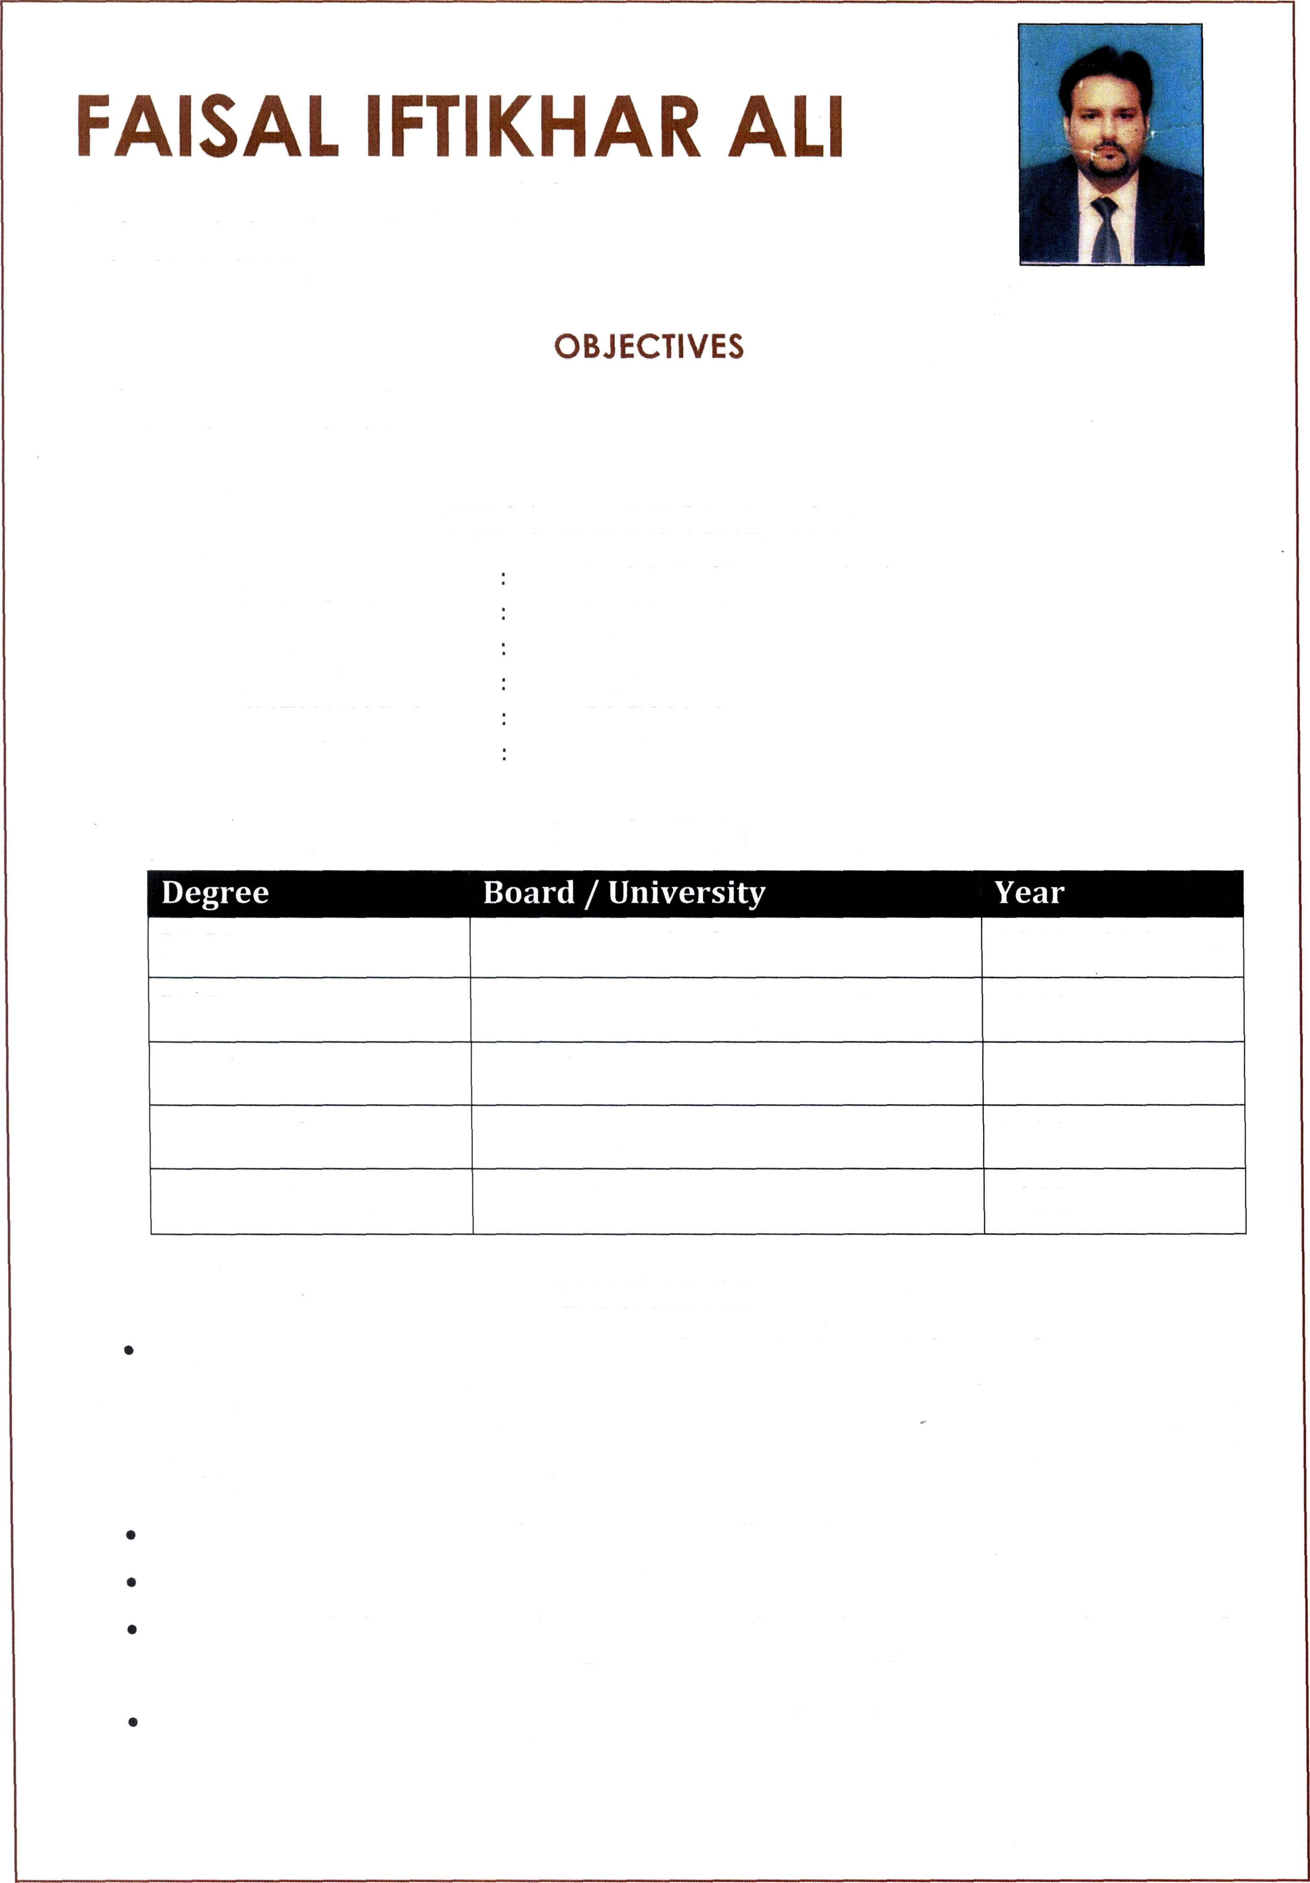

LL.M | University 0f Lahore | 2014-2016
LL.B | Punjab Universi/ (Law College) | 2011
Graduation | Punjab University | 2003
Intermediate | BISE Lahore | 2000
Matriculation | BISE Lahore | 1998

EXPERIENCE
Working as Associate Advocate with Mr. Muhammad Saleem Shahnazi, Advocate Supreme Court, in Shahnazi Law Chamber, Dffice No. 27 & 28, Memoona Subhan Centre, Farid Kot Road, Lahore dealing in Civil, Criminal & Family Matters Practice Since Nov 2010 to till Dct 2020.
Visiting Law Lecturer at Punjab University Law College Lahore.
Visiting Law Lecturer at National Law College Lahore.
Working as “Sub-Examiner” for LL.B. Papers (Annual & Supplementary) in Punjab
University, Lahore Since 2013 to till date.
Whole Time Law Lecturer at Himayat -e-Islam Law College Lahore.

- Peaceful Mind
- Customer Dealing
- Customer Relationship
- Punctuality

Good Communication Skill
- Good Team Member
- Self MOtlvated

Fundamental 0f Computers
COMPUTER SKILLS

- Typing Master: Having Typing Speed Approximately 45WPM

Microsok Word
- MiCrosoñ Excel

Microsok Power Point
- Microsoñ Outlook
- Soñware Installation
WlRdow Installatlon
- Internet BrOWSlR Q

English
- Urdu

Punjabi

Will be furnished on demand
LANGUAGES

REFERENCE

